**Title**

15th World Conference on Advances in Nanoscience and Nanotechnology

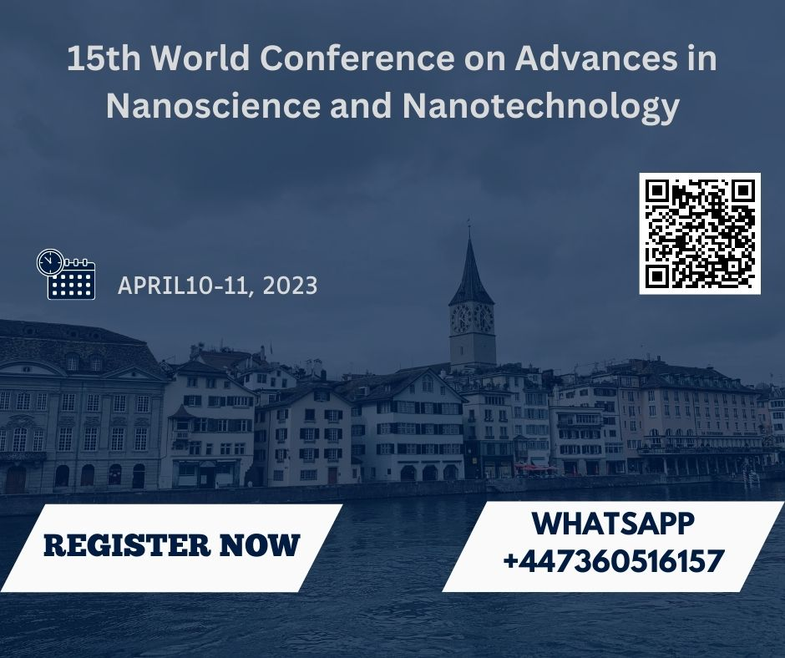

**Date and venue**

April 10-11, 2023 Zurich, Switzerland

**Theme**

Transforming all the boundaries by reflection on advances

**Announcement**

This is a great opportunity for many researchers to exchange ideas with the world's top experts on new advances and innovations in the field of nanotechnology. On behalf of the Organizing Committee, we warmly welcome all participants and delegates to the 15th World Nanotechnology Congress in Zurich, Switzerland on 10-11 April 2023. Applications of nanoscience and nanotechnology have developed remarkably in recent years and continue to hold great potential for society as a whole. Advances in fuel cells, vaccines, batteries and building materials are all enabled by the efficient application of nanotechnology. Nanotechnology may also be needed to combat environmental destruction.  
However, man-made nanoparticles with new properties may harm the environment and people. Such risks are still under investigation due to the increasing diversity of nanomaterials and their adaptability.

**Call for abstract**

"Transforming all the boundaries by reflection on advances" will be the theme of the 15th World Conference on Advances in Nanoscience and Nanotechnology.

In order to provide comprehensive worldwide discussions that address current issues in Nano Science 2023, keynote and speakers sessions on the latest cutting-edge research are also included.

To any of the above mentioned tracks, submit you’re abstract. By choosing a package that really is suitable for you, register for the conference pretty quickly.

**Nanomaterials, Tissue Engineering, Nano-Electronic Devices**, Nano-fabrication**,** **Bio-hybrid polymer, Nano-robotics, Automation and Assembly, Nano based vaccines, Nano-medicine, Nano-pharmaceuticals**

**Reason to attend**

To help people and the industries they work in advance their careers and skills, this world conference on nanotechnology has the opportunity to do so.  
This allows people from different backgrounds to come together to discuss meeting ideas and meet their needs.

The Nanotechnology Conference 2023 audience is multidisciplinary and includes business, diverse technology and planning departments, corporations, and upstream

Researchers.

**Audience**  
  
Nanotechnology Researchers and Scientists  
Junior/Senior Research Fellows in the Fields of Nanotechnology, Materials Science, Polymer Science and Biotechnology  
Materials Science and Nanotechnology Students  
CEOs of Companies Using Nanotechnology engineer

**Market analysis**

As part of their expert research on the Global Nanotechnology Market Outlook 2024, researchers have analysed key market trends and developments to identify areas where the industry offers potential opportunities to accelerate its expansion. Researchers have explored key industry changes and trends to identify sectors that can provide opportunities for companies to accelerate their expansion. The global nanotechnology market was valued at $1,055.1 million in 2012 and is expected to grow 10.5% annually to $2,231.4 million from 2022 to 2025. Market growth in many areas, including semiconductors and electronics, has resulted in increased applications for materials such as nanotubes, Nano robots, nanofibers, and Nano devices. Faster and more efficient systems can be built using nanotechnology to make devices lighter, thinner, with better screens, lower power consumption, and better on-chip storage.

Opportunities  
one of the key market opportunities is the expected increase in demand for self-powered nanotech gadgets in the near future. To be self-sufficient and maintenance-free, the system must be able to draw energy from its surroundings and store it for later use. For example, environmental sensors help identify contaminants without spare batteries, while implanted biosensors are used to monitor blood sugar levels in patients. Wireless Nano devices are becoming increasingly important in fields such as medical, defence, and personal electronics. Therefore, researchers are striving to integrate multifunctional Nano devices into Nano systems in order for them to perform biological functions (such as sensing, communication, and control of system operation).

**Benefits**

The global nanotechnology market is expected to expand moderately during the forecast period. Nanotechnology is increasingly used in healthcare, nanotechnology devices are technologically advanced, nanotechnology devices are used in extreme weather conditions, etc., boosting the growth of the market. Moreover, the market is expanding due to increasing demand for engineered nanomaterials in cosmetics and food, development of self-powered nanotechnology devices, and increasing government investment in nanomaterials, Nano devices, and nanomedicine.  
  
Segment Pharmaceuticals, Energy & Utilities, Electronics, Chemicals, Aerospace & Defence, and Other segments of the Nanotechnology market are segmented by application, along with other segments including Food & Beverages, Personal Care, and Automotive.  
  
The pharmaceutical business is expected to grow the fastest of all of these during the forecast period. This is mainly due to the use of nanotechnology in drug delivery, imaging and detection of diseases such as cancer and atherosclerosis, and treatment of hearing and vision problems.